**Azure API Management** offers a scalable, multi-cloud API management platform for securing, publishing, and analyzing APIs.

**API Management components**

Azure API Management is made up of an API *gateway*, a *management plane*, and a *developer portal*. These components are Azure-hosted and fully managed by default. API Management is available in various [tiers](https://learn.microsoft.com/en-us/azure/api-management/api-management-features) differing in capacity and features.

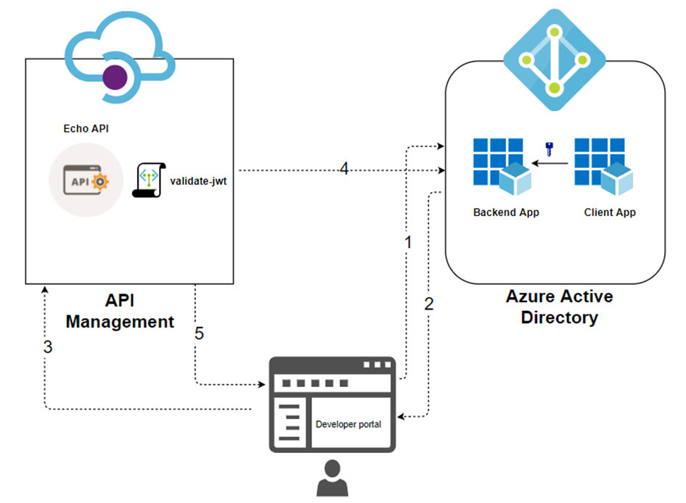

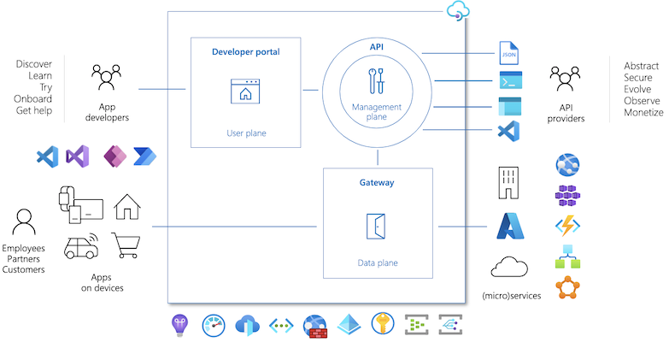

<https://www.c-sharpcorner.com/article/azure-api-management-apim-overview/>

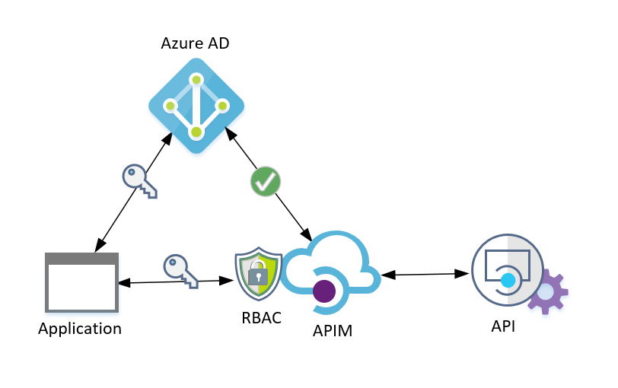

**Audience is the backend**

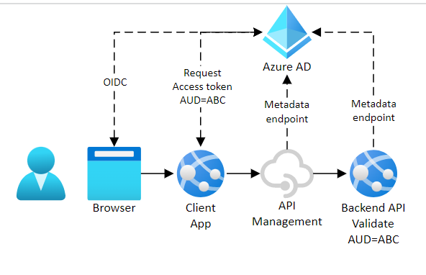

* ***API gateway*** is the endpoint that:
  + Accepts API calls and routes them to your backends.
  + Verifies API keys, JWT tokens, certificates, and other credentials.
  + Enforces usage quotas and rate limits.
  + Transforms your API on the fly without code modifications.
  + Caches backend responses were set up.
  + Logs call metadata for analytics purposes.
* The ***Azure portal*** is the administrative interface where you set up your API program. Use it to:
  + Define or import API schema.
  + Package APIs into products.
  + Set up policies like quotas or transformations on the APIs.
  + Get insights from analytics.
  + Manage users.
* The ***Developer portal*** serves as the main web presence for developers, where they can:
  + Read API documentation.
  + Try out an API via the interactive console.
  + Create an account and subscribe to get API keys.
  + Access analytics on their own usage.

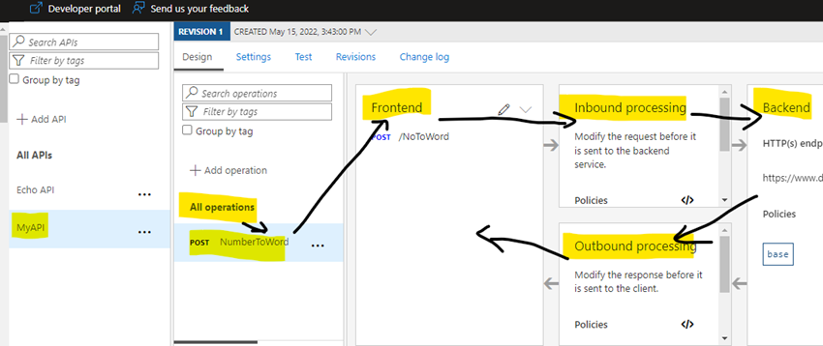

**Headers**

Content-Type: text/xml;charset=utf-8

Ocp-Apim-Subscription-Key: dd0bd20*********8***fc7da0

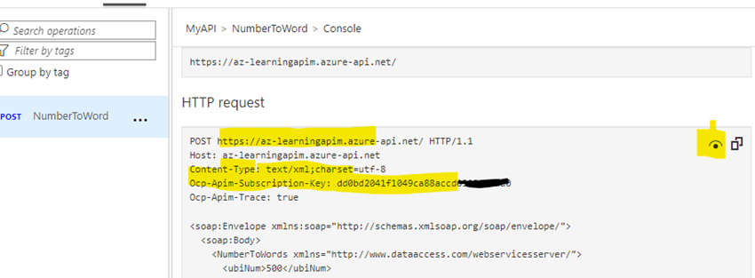

Put the above details into postman app and send the request.

